|  |
| --- |
| ITC Project REPORT |
| Kasyap V Karun B130241EC Christy George B120885EC |
| Date : 20/06/14 |

ITC Project Report

AIM

It is desired to generate the decoder and encoder circuitry for hamming code or (7, 4, 1) BCH code.

Block Diagram

Encoder

Decoder

Components Used

* XOR Gate IC – 74HC86
* Parallel to Serial Conversion IC – 74HC165
* Parallel to Serial Conversion IC – 74LS595
* LEDs - High Brightness
* Breadboard
* Connecting Wires

Theory

Hamming code generates 7 bit code words from 4 input message bits. We used systematic generator matrix in which four out of seven transmitted bits are message bits and the other three bits are parity bits. The generator matrix is given below;

The parity check matrix is used for generating 3 bit syndrome at the receiver side. The parity check matrix is given by;

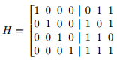

Each syndrome denotes error in corresponding bits in received sequence;

|  |  |
| --- | --- |
| Syndrome | Error Bit |
| 000 | No error |
| 001 | R3 |
| 010 | R2 |
| 011 | R5 |
| 100 | R1 |
| 101 | R7 |
| 110 | R4 |
| 111 | R6 |

Circuit Diagram

Encoder

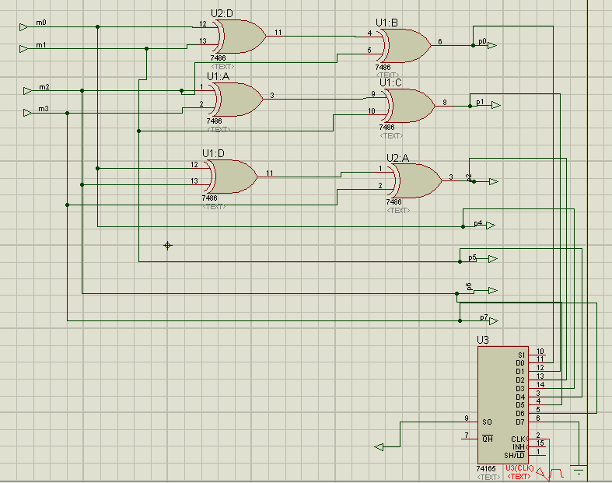

Decoder

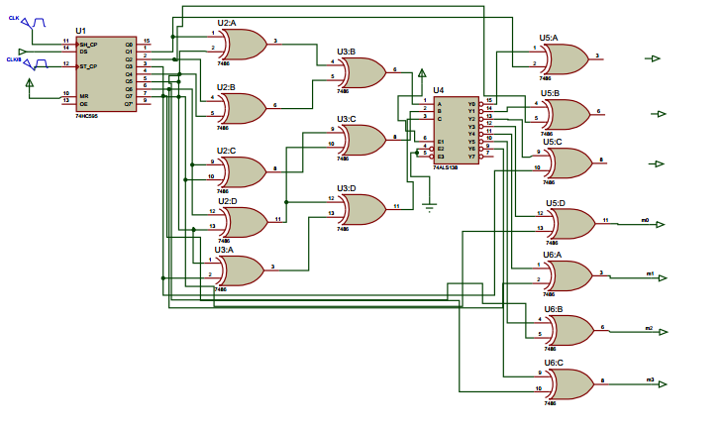

Inferences

1. 74LS595 IC needed two clock pulses, one is one-eighth of the other.
2. It should be careful that serial to parallel IC and parallel to serial IC are synchronized.
3. The output from decoder IC is active low, so that the output from decoder is also active low.